THE UNITED CHURCH, WINCHESTER
Please read the attached conditions of hire and then complete Section A, sending it to your church contact who may confirm the booking by completing and emailing Section B
- Email Application to Hire Church Premises
This Application is made by / on behalf of (‘the Hirer’): (please specify the Hirer’s name.)
To use: (please specify the rooms and equipment required.) (‘the Premises’)
On the following date(s) / day(s) / times(s): (for example: this can be for specific dates or for a specific time each week / month, and (with the Owners’ consent) can allow for future dates to be separately agreed by email.)

‘End Date’: (no more than 13 months from the first use.)

For the following event / purpose (‘the Purpose’):

- Title / type of event / purpose:
- Anticipated content / activities:
- Food / drink.  N.B. If you wish to serve alcohol, approval is required. Please ask for details | Yes / No (delete as applicable)  If Yes, please provide details.
- Maximum number of persons anticipated to use the Premises on each hire (300 maximum in whole building and 200 maximum on ground floor):
- How many users will be children:
By making payment of the Hire Charge(s) and/or occupying the Premises the applicant Hirer acknowledges that:
- This Application is made subject to the Conditions of Hiring Church Premises (‘the Conditions’) and the ‘Rules and Regulations’ which have been read, understood and accepted by the Hirer and will be observed by the Hirer and all those persons using the Premises pursuant to this Application, but in the event of any discrepancy between the Conditions and the information in this Application, the provisions of this Application shall prevail.
- The Hirer has read, understood and agrees to follow the Owners’ Evacuation and Fire Emergency Plan.
- The Hirer confirms they will have a Safeguarding Policy in place and will implement it. The Hirer will respond without delay to every complaint which suggests that a child, young person or adult at risk has been harmed or is at risk of harm and co-operate with the police and Children’s and Adult Services in any investigation.
- This Hiring Agreement is not intended to confer exclusive possession on the Hirer and accordingly no tenancy of the Premises is intended to be created. The Premises remain under the control of the Owners who reserve the right to enter the hired space at any time and for any reason. Where any temporary storage facilities are provided under this Application this is not on an exclusive basis and the Owners reserve the right to relocate any stored goods at any time and for any reason.

Signature or name of applicant Hirer:
Date:
Position in group / organisation on whose behalf this application is made, if applicable:
Full address including postcode:
Telephone Number(s) (day) and (evening):
Email address:
- Email Booking Confirmation
Subject to complying with the terms of the Booking Confirmation as detailed below, the Owners confirm that your Application has been accepted as confirmed below.
Hire Charge(s):
Terms of payment: | 14 days from date of invoice
Notice Period: (for example: 7 days.) | Hirer: 7 days  Owners: 7 days, but any unexpected urgent church requirements will take precedence over any booking.
Signature or name of Owners’ Agent:
Date:

THE UNITED CHURCH, WINCHESTER (‘the Church’)
CONDITIONS OF HIRING CHURCH PREMISES (‘the Conditions’)

- In the Conditions:
  - ‘The Application’ means the accepted application to hire premises.
  - ‘The Owners’ means The United Reformed Church (Wessex) Trust Limited, the Church or their Agent.
  - ‘The Hirer’ means the person making the Application and any group / organisation for whom he / she is acting. Any liability under the Conditions of such person and such group / organisation shall be joint and several.
  - ‘The Premises’ means the areas, spaces, facilities, equipment and parking spaces more particularly defined and agreed in the Application and the access provision thereto.
  - ‘Rules and Regulations’ means any rules made by the Owners from time to time for the use of the Premises, including any shared areas or facilities.
Payments
- The Hirer shall make all payments to the Owners in the manner and on the due dates agreed in the Application.
- The Owners reserve the right to review and increase the Hire Charge(s) payable pursuant to the Application.

Use of premises
- The Hirer acknowledges that this hiring agreement confers permission to access and use the Premises only for the Purpose on the date(s), day(s) and times(s) agreed in the Application, the benefit of which cannot be assigned to any third party, and further that no relationship of landlord and tenant between the Owners and the Hirer or any other rights of occupation are created.
- The Hirer is responsible for ensuring that not more than the number of persons agreed in the Application shall be allowed in the Premises at any one time.
- Where keys, keycards or access codes are issued to the Hirer, the Hirer acknowledges that the keys or keycards: remain the property of the Owners; are for the use of the nominated keyholders only; are not to be copied or passed to any other person, and where an access code is provided to the Hirer, that they must remain confidential and not be communicated to any other individual. Keys cannot be issued to anyone who has been convicted or cautioned concerning abuse of children, young people or adults at risk.
- The Hirer acknowledges that the Owners give no warranty that the Premises are legally or physically fit for the hire.
- The Hirer acknowledges that all persons using the Premises or bringing belongings onto the Premises do so entirely at their own risk.
- The Hirer or another authorised person of any group / organisation for whom he / she is acting shall be present throughout the hire period to be responsible for the safe and efficient supervision of the Premises, including but not limited to the effective control of all persons present and the orderly and safe departure of all persons from the Premises in the case of an emergency evacuation.
- The Hirer acknowledges that there is no parking provision on site except to the extent agreed in advance and in writing by the Owners.
- The Owners reserve the right to enter the Premises and remain on the Premises during the hire at any time.
- The Owners may put a stop to any hire which in their opinion is not properly conducted or does not respect the special status of the Premises, or which may interfere with the activities of the Owners or other hirers, or which may infringe any of the Conditions, or which might compromise the ministry and mission of the United Church.
Compliance with rules and regulations
- The Hirer must comply with all Rules and Regulations where they have been provided to the Hirer either in writing or by email.
- The Hirer is responsible for complying with all laws and regulations relating to their use of the Premises and for obtaining and paying for any consents, licences (unless a relevant licence is already held by the Owners) and permits (which for the avoidance of doubt includes any Performing Rights Society Licence and Temporary Event Notice) required to lawfully use the Premises for the Purpose intended. Further to which the Hirer must also obtain any particular licences required for public / theatrical performances involving music, singing and dancing, and if copyright material is used or performed, the permission of the owner of the copyright.
- The Hirer acknowledges that to comply with current legislation, smoking and the sale of alcoholic beverages are not permitted on any part of the Premises. Alcohol may not be served on the premises without the prior consent of the Church Council. An application form with detailed conditions is available from the Facilities Manager: facilities@ucw.org.uk
- The Hirer acknowledges that pets and animals (except assistance animals) are not permitted in the Premises except to the extent agreed in advance and in writing by the Owners.
- The Hirer must not bring into the Premises any contaminative or hazardous substances, or anything of an especially combustible, inflammable or explosive nature.
- The Hirer must not display any form of external advertising at the Premises, except to the extent agreed in advance and in writing by the Owners, but may appropriately signpost their location during the period of a hire session. This is recommended if the Coffee Bar is open (10am to 12 noon weekdays).
Safeguarding
- The Hirer is responsible for ensuring that when children, young people or adults at risk are present on the Premises the appropriate legislation and best practice in connection with their supervision and safety is observed.
- The Hirer is responsible for ensuring that children, young people and adults are protected at all times by taking all reasonable steps and by having any necessary insurance in place.
- The Hirer must respond without delay to every complaint which suggests that a child, young person or adult at risk has been harmed or is at risk of harm and co-operate with the police and Children’s and Adult Services in any investigation.
- The Hirer must abide by their own Safeguarding Policy.
Public safety
- The Hirer must abide by the Church’s Evacuation and Fire Emergency Plan.
- The Hirer must not obstruct any means of exit from the Premises.
- The Hirer must observe all relevant food health and hygiene legislation.
- The Hirer must ensure that any electrical appliances brought onto the Premises are safe, in good working order and used in a safe manner. A valid PAT test certificate may be used to evidence this.
- All accidents involving injury to members of the public must be recorded in the appropriate accident book and be notified to the Owners as soon as possible.
Repair, damage, insurance and indemnity
- The Hirer is responsible for any loss or damage to the Premises (which for the avoidance of doubt includes its electrical installations) and for any loss, theft of, or damage to any property on the Premises (which for the avoidance of doubt includes any fittings or furnishings belonging to the Owners) arising out of the hire, or while persons are entering or leaving the Premises pursuant to the hire, howsoever and by whomsoever caused.
- The Hirer is responsible for any loss, damage, injury or expense which may be suffered by or be done to or happen to any person, arising out of the hire, or while persons are entering or leaving the Premises pursuant to the hire, howsoever and by whomsoever caused.
- The Hirer must ensure that no bolts, nails, screws, pins, spikes or other objects are driven into the fabric or furnishings of the Premises, and that no adhesive products are used on the walls of the Premises.
- The Hirer must report any matters of potential interest to the Owners, such as damage, howsoever caused or arising from their use of the Premises, or their breach of the Conditions, whether directly or indirectly in any manner whatsoever.
- The Hirer shall indemnify the Owners from and against any loss, damage or theft of any property, or any other demands, actions, proceedings, losses, damages, costs, expenses, claims and liability from any person, howsoever caused or arising from their use of the Premises, or their breach of the Conditions, whether directly or indirectly in any manner whatsoever.
- The Hirer acknowledges that the Owners’ Public Liability Insurance does not extend to external hirings, that the Hirer is strongly advised to arrange their own Public Liability Insurance, and that the Owners reserve the right to insist that such insurance is arranged and a copy provided.
- The Owners are not responsible for any loss due to any breakdown of machinery, failure of supply of electricity or gas, leakage of water, fire, government restriction or Act of God, which may cause the Premises to be temporarily closed or the hire to be interrupted or cancelled.
End of each hire session
- The Hirer must fully vacate the Premises by the time agreed in the Application.
- Any property brought into the Premises for any reason arising out of the hire session or otherwise, must be removed at the end of each hire. The Owners shall not be responsible for any property left behind in any event.
- The Hirer must not store any property on the Premises, except to the extent agreed in advance and in writing by the Owners. Where permission is granted, this is not intended to confer exclusive possession on the Hirer and no tenancy of the Premises is intended to be created. The Owners reserve the right to relocate stored goods at any time and for any reason.
- The Hirer must at the end of each hire session return any borrowed or hired items, equipment and furniture to their original location.
- The Hirer must at the end of each hire session ensure that the Premises are left in a clean, orderly and smoke free state. Failure to adequately clean the Premises and remove all rubbish arising from the hire may result in an additional charge for cleaning.
- The Hirer must at the end of each hire session ensure that all lights and appliances are turned off and that the Premises are left securely locked (which for the avoidance of doubt includes the locking of all doors and windows). All internal doors must also be closed as many are fire doors.
Termination of hiring agreement
- The Owners reserve the right to cancel any hire on giving not less than the Notice Period specified in the Application (except in the event of emergencies when less notice than the Notice Period may be given) and to cancel the hire at any time in the event of any material breach of the Conditions.
- The Hirer must give the Notice Period specified in the Application to the Owners of any cancellation of the hire, otherwise the applicable Hire Charge(s) will be payable.
- Service of such cancellation notices is sufficient if it is in writing or by email to the Hirer or to the Owners’ Agent.
- The hiring agreement terminates on the specified End Date unless terminated earlier.
- The Hirer must return any keys or keycards to the Premises which have been issued at the earliest opportunity following the end of the hiring agreement. A written receipt for the keys or keycards must be obtained.

THE UNITED CHURCH, WINCHESTER
RULES AND REGULATIONS FOR HIRING CHURCH PREMISES (‘the Rules and Regulations’)

- These Rules and Regulations are supplementary to the Conditions of Hiring Church Premises as set out in 1.5 of the Conditions.
- If the kitchen has been used, the Hirer must ensure kettles are emptied, the boiler is switched off and the dishwasher drained.
- No food or drinks are permitted in the Sanctuary (Church), only bottled water.
- Following the recommendation of the Methodist Church, raffles or small lotteries may be held at fundraising functions, usually for donated prizes and subject to the following rules:
- The only expenses which can be deducted are those of printing the tickets and purchasing prizes.
- The sum spent on prizes must not exceed £50.
- None of the prizes may be cash prizes.
- If you discover a fire:
- Raise the alarm using one of the call points.
- Telephone the emergency services by ringing 999 or 112 on a mobile and give the following details:
  - Your name
  - Address: The United Church, Jewry Street, Winchester, SO23 8RZ
  - The nature of the fire
  - The road at the rear of the building is Printers Row, leading to Staple Gardens; and the flats behind The United Church are called Fabers Yard.
- Encourage everyone to leave the building promptly and calmly by the nearest exit: front door, Chapel door or back door.
- Assemble in Jewry Street or Staple Gardens, depending on exits used, and check for missing persons.
- Contact a representative of the Church as soon as possible and provide details of the event:
Tim James 07925 691260
Christine Cook 07771 810536 or 01962 884510
Robin Cook 07976 123385 or 01962 884510
- The premises shall not be re-entered until:
  - The reason for the alarm has been addressed; and
  - The fire alarm has been reset by either the fire brigade or an authorised church representative.
  - Use of fire extinguishers
- If in any doubt, do not use a fire extinguisher. Raise the alarm, evacuate the building and phone the fire brigade.
- If using a fire extinguisher, use the correct type for the fire.
- Be accompanied when attacking the fire.
- Keep a clear means of escape behind you.
- Evacuate if the fire becomes bigger or the risk of being trapped increases.

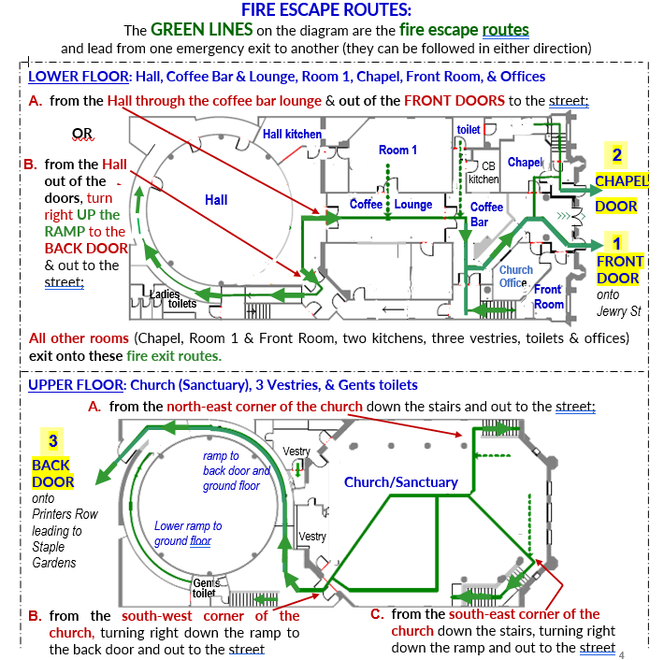

THE FOLLOWING IS FOR INFORMATION ONLY
FIRST AID KITS, DEFIBRILLATOR & EVAC CHAIR
First Aid Kits: located in the Hall kitchen, Coffee Bar kitchen, Sanctuary/Church (near the sound system) and Office – where the accident report book is located.
Defibrillator: on the wall in the Coffee Bar near the Servery.
EVAC Chair: in the Sanctuary/Church (for use to evacuate down the stairs at the front of the building if the ramp to the rear exit is blocked).

DOOR BELLS
Door bells are located at the front single door and back door. A portable receiver is located on the ledge outside the office. This can be taken into the room for your event and the settings adjusted (bell and flashing light, bell only, flashing light only). Please ensure it is set at ‘bell and light’ when replacing on the ledge after your event.

KEY COLLECTION & RETURN
Please agree times with the Facilities Manager: facilities@ucw.org.uk

OPERATING THE AUTOMATIC FRONT DOORS
We recommend using the automatic front doors for larger groups of people. When unlocked, these should never be left unattended (except in an emergency) even if other users are in the building.
The doors are operated as follows:
- Unlock the doors by turning the two twist locks as shown;
- Turn the switch on the wall in the foyer (below the light switches) to AUTO;
- Ensure you have allocated someone to only permit authorised attendees entering the building.
- During your event, if there is no-one supervising the doors, switch to OFF on the wall but leave unlocked to provide a faster exit in the event of an emergency.
- When leaving after your event, ensure the switch is at OFF and the turn the twist locks to lock the doors.
The doors must be locked when leaving. The single front door can be used to exit the premises; this must be fully closed behind you.

